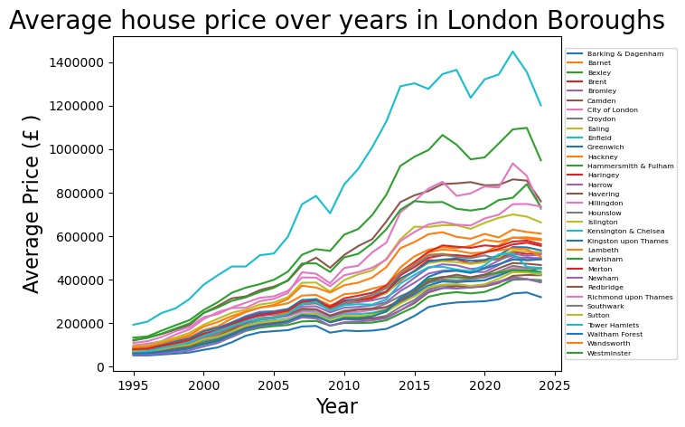
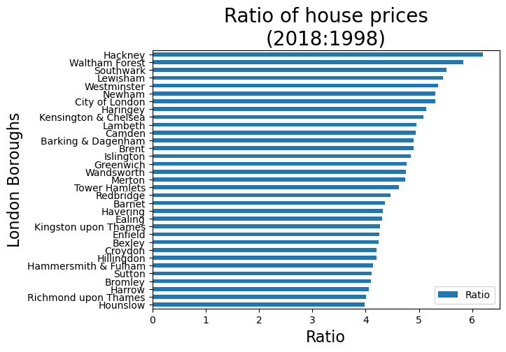
Q1. What did you find? Which borough is the most expensive? Any other interesting trends?
From the first graph, following observations can be made.
- Across all boroughs, house prices generally followed the same trend over the years.
- Kensington & Chelsea consistently held the most expensive properties, while Barking & Dagenham remained the most affordable.
- Significant price drops occurred in 2008 (likely due to the global financial crisis) and 2022 (possibly due to the COVID-19 pandemic). Prices showed signs of stagnation after 2015.
From the second graph, following observations can be made.
- There is a significant increase in average house prices across all London boroughs, ranging from 298% to 520% over the two decades from 1998.
- Hounslow experienced the lowest growth (around 300%), while Hackney saw the highest (around 520%).
- The absence of a single outlier suggests that multiple factors likely contributed to price changes over time.
Q2. How did you arrive at your conclusion?
The provided visualizations effectively conveyed the key trends in London's borough house prices, overcoming the deficiency of a simple table. The first graph made evident the average house price for each borough and its trajectory over time. Price drops and slowdowns became readily apparent, facilitating quick comprehension.
The second graph excelled at showcasing price changes over two decades from 1998 by showcasing the ratio of the average price in 2018 with respect to average house prices in in 1998 for every borough in greater London. Both graphs worked together to reveal the absence of significant outliers in price change trends. Deviations from the general pattern would have caused a borough's line to cross over others in the first graph. While a sing very large or a very small ratio would have been much more visible in second graph suggesting the presence of an outlier resulting from significant investment (or changes in available facilities) or lack thereof in a single borough.
Q3. What were the main challenges you encountered? How did you overcome them? What could you not overcome?
This project presented a few hurdles that I was able to overcome:
Unintroduced Variables: Some variable names appeared in later sections without prior explanation. For example, "month" wasn't mentioned while melting the DataFrame, but later instructions requested a "month" vs. average house price plot. I initially attempted to extract only the month data, excluding the year. This wasted time as the goal, as clarified by Tier 1 instructions, was to plot average house prices vs. the entire date. In such cases, Tier 1 instructions proved invaluable for clarification.
Version-Specific Issues: Certain methods or functions triggered warnings or errors. These were often due to differences between my installed versions of pandas or Python and the versions used in the project instructions. Fortunately, most issues were resolved through web searches.

Persisting Error: One specific error message remained unresolved despite online research. I've included the message below for further assistance
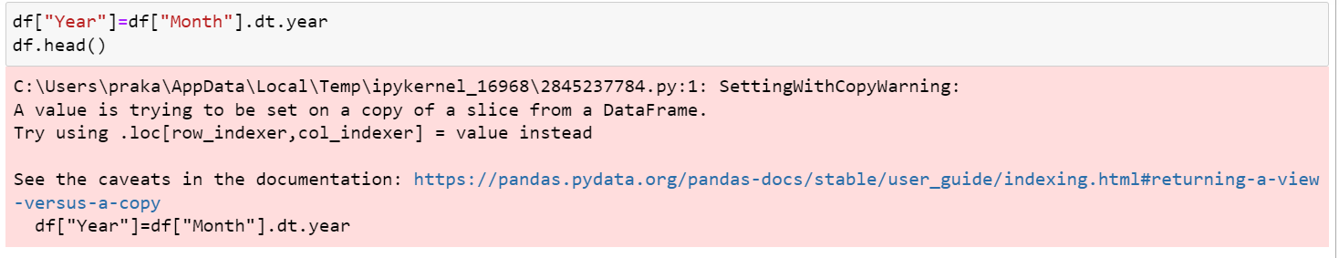
Q4. Is there anything you’d like to investigate deeper?
While the project successfully addressed the core requirements, there were several interesting avenues I'd have liked to explore further, given more time and a broader scope:
Quantifying Price Drops: Calculating the precise percentage price drops in 2008 and 2022, potentially correlating them with the global financial crisis and the COVID-19 pandemic, would offer valuable insights.
Rate of Change Analysis: Comparing the rate of price change between two distinct periods, 1995-2015 (potentially exponential) and 2015-2024 (possibly flat), would reveal how market dynamics have shifted over time.
Absolute vs. Relative Price Changes: Investigating both absolute and relative price changes would provide a more comprehensive picture. Absolute changes could involve setting the starting house price in 1995 to zero, showcasing the true price gain. Relative changes could track price movements as a percentage of the initial value year-on-year, highlighting market fluctuations.

